# Is this prompt effective?

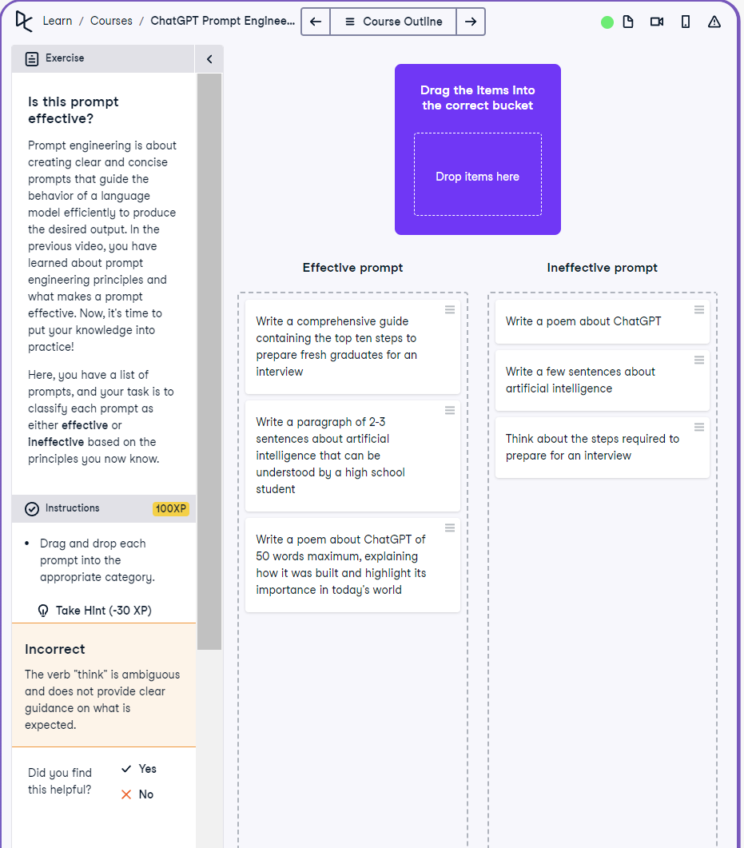

## Question

Classify prompts as either effective or ineffective based on prompt engineering principles.

## Question Explanation

This exercise helps develop prompt evaluation skills. It requires identifying which prompts are clear, specific, and actionable based on best practices in prompt engineering, and separating those from vague or ambiguous ones.

## Answer

Effective Prompts:  
1. Write a comprehensive guide containing the top ten steps to prepare fresh graduates for an interview.  
2. Write a paragraph of 2-3 sentences about artificial intelligence that can be understood by a high school student.  
3. Write a poem about ChatGPT of 50 words maximum, explaining how it was built and highlight its importance in today's world.  
  
Ineffective Prompts:  
1. Write a poem about ChatGPT.  
2. Write a few sentences about artificial intelligence.  
3. Think about the steps required to prepare for an interview.

## Answer Explanation

Effective prompts are detailed, specific, and set clear expectations. For example, specifying a word limit, audience, or structure makes the task more achievable for the model. Ineffective prompts are vague, lack constraints or clarity, and leave too much open to interpretation.